Lab 9 manual: Helmholtz coils (Tracker)
Dr. D. Beznosko
6/15/2026
For PHYS 1112L only
(Lab outcomes: magnetic field reconstruction, comparison of data with theory is done without fit in this lab using Bayesian approach.)

Abstract
The objective of this laboratory is to measure the magnetic field from the two Helmholtz coils with the electric current. The result is compared with the theoretical value within errors. The provided template should be used for analysis.

Introduction
Hermann von Helmholtz was a German-born scientist who has made fundamental contributions to multiple fields such as physiology, optics, electrodynamics, mathematics, and meteorology. Remember to reference historic information as well! What are Helmholtz coils and how do we use them today? Think of lab 8!

Experimental Setup
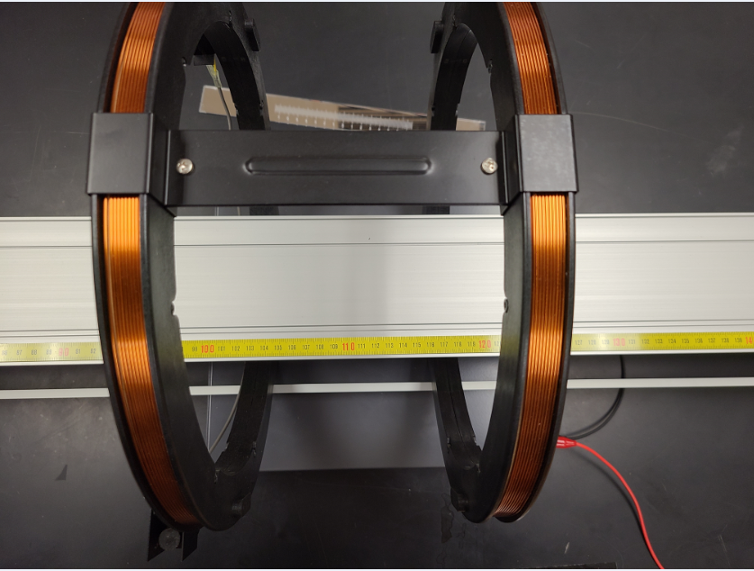
Shown in Figure 1, the experimental setup that consists of the cart track, two multimeters, e/m apparatus coils, power supply and PASCO [1] magnetic field sensor (not shown).
e/m apparatus coils only
Cart track
Wires to power supply and multimeters
Figure 1: The experimental setup schematic. A magnetic probe is not shown.

Procedure
There is a video file that is attached to this lab – you are welcome to watch it to see how the experiment was done. However, we are not using it for any analysis. Use the video to write the procedure.
The magnetic field total strength vs. position is provided as an .xlsx file. The readings of the multimeter are shown in the image attached (also in the video). Which one do we need? What is the error on this reading? (check out the analysis template as well, see D2L announcements)

Experimental Data
The results of the measurements should be organized as Table 1 or similar. Think about how to organize this table. The error can be listed in a different column or as value ± error unit. Don’t include all data values here, only relevant means, stdev etc. In most cases, individual data points are not needed, especially for computer-based labs. What is the current I error? What are other parameters we need here? Do not actually include a table with magnetic field and position data as it’s already provided to you and it’s exceptionally long. A plot of raw data only will be sufficient!
Table 1: Experimental data. Use it for the values that are constant for the experiment, like current, offset…
Position, m | Magnetic field, G | Current, A

Provide a description of each entry as needed in the section text, do not just leave the able without text in this section. Organize well so that data takes up less space, but everything needed is included.

Theory
When a current I passes through a loop of radius R, the magnetic field strength $B$ along the axis through the center of the loop and a distance $x$ from the center of the loop is given by:

$$B=\left(\frac{μ_{0}I}{2}\right)\frac{R^{2}}{{\left(x^{2}+R^{2}\right)}^{3/2}}\left(1\right)$$

(Make sure that symbols in eq. 1 are described in text. See how in this case they are explained before the equation and not after? This is also acceptable.)
Derivation of equation 1 assumes that the origin of the coordinates is located at the loop center. If the origin does not coincide with the center of the loop but is instead a distance $x_{0}$ from the loop center, we must replace $x$ in equation 1 by $\left(x−x_{0}\right)$. Moreover, if the loop consists of $N$ turns, each carrying a current $I_{0}$, we can replace the current $I$ by $NI_{0}$. With these considerations, equation 1 becomes
$$B=\left(\frac{μ_{0}NI_{0}}{2}\right)\frac{R^{2}}{{\left({\left(x−x_{0}\right)}^{2}+R^{2}\right)}^{3/2}}\left(2\right)$$
As we have two coils, we will need to use eq. 2 twice, indicating their different positions, such as $\left(x_{1}−x_{0}\right)∧\left(x_{2}−x_{0}\right)$.

If all quantities on the right-hand side of equation 2 are entered using SI units, then B field magnitude value will be in tesla, T. Hint: you may need conversion to Gauss! What is the relationship between units of Tesla and Gauss?

The coils in Figure 1 are separated by the distance that is equal to their radius R. So, if we input the proper positions of the centers of the coils into equation 2, then:

$$B=B_{1}+B_{2}\left(3\right)$$

Show the resultant equation from equation 3 after substituting equation 2 into it twice, once for each coil in the setup!

Analysis
We use only Excel for analysis here. You are comparing the measured data points with the points produced using resultant equation 3 that has all parts in it. See the template, as it contains most of the tasks described in this section.
For the coil properties, check out https://cdn.pasco.com/product_document/012-14265C.pdf or google for the PASCO e over m apparatus and read the documentation. While the manual gives N and R, they do not give errors. Assume an error for N and R – what do you think is the error for these values? The average radius R is the center of the coils, what is the reasonable error to assume? For N, just use it as a perfect value. You may use $μ_{0}$ as perfect – check out the error on the known value, its tiny compared to other error contributions in our experiment.
Find the expression and value of error for $ΔB$ for the resulting equation from eq. 3? This is your error from theoretical calculations. You also have the measurement error for B. Add theoretical $ΔB$ with the experimental error in quadrature as usual as we will need a single value of error for finding $χ^{2}$.
Let’s estimate the statistical error for the B-field measurement. You will notice that the first values in the data all have the same position value of 0. (Similar for the last ones as well – they all have the same position value). Do the stdev for all B-field values with the same 0 position. This is your statistical error. (Note: you can do the same for the points at the end of the data and average the results. Just don’t mix in the same stdev function data from start and end!)
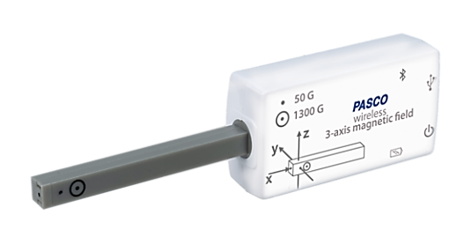
Use the image with coils and track to find the approximate position of the center between the coils on the ruler. The 0 cm position is our origin of the coordinates, and every calculation must be done relative to it. Don’t worry about being too exact, you will adjust this value later. Use SI units (that is, meters!!!). From here, we can find the positions of the centers of coils one and two as $x_{01}=center−\frac{R}{2}$ and $x_{02}=center+\frac{R}{2}$.
With data, we also need to offset the coordinates. The cart sensors assume the starting position as 0, but from the image with cart and magnetic sensor probe we clearly see that this is not the case. Find the position of the circled dot that pointed to by orange arrow in the image here using the ruler in the image provided. This is the offset that you need to add to all positions from the data file before proceeding any further. Use meters and don’t worry about the exact value as it will be adjusted.
Plot the experimental data vs position avoiding the repetitive positions at the start and end of data. Basically, only where position value changes should be plotted.
Using the result from equation 3, create a column with the theoretical values for the B-field using offset positions as well! Don’t use the beginning or end portions of data, when the cart just sits there, or the value of B-field is too low!
Overplot these values vs offset position on the same graph as the data for the same position values. Reminder - don’t use the beginning or end of data!
Adjust center position value and offset (and current I within its error) so that visually the data and the predicted values match. The template indicates which values need to be adjusted, don’t adjust cells that have equations in them!
Next, note that the values at non-changing positions (say, at the data start) do not match with predicted values too well (provided that visually the center of your plot matched well). This is because there is also a systematic offset for the sensor. Take the difference between an average of several data points and a theoretical value at the same distance and use this as systematic error. Add it with the statistical in quadrature and use it as a total B-field error!
Calculate the ${χ^{2}}/{ndf}$ for the relevant data points (that is, between calculated and measured points). Here, $ndf$ is a number of points that you used, as there is no fit function used. Adjust center position value and offset (and current I, all within their error) so that the ${χ^{2}}/{ndf}$ is minimized (that is, as close to 1 as possible, or even less than 1), and find the p-value as well. How well do your data and theoretical prediction match? What does it tell you about the B-field of the Helmholtz coils? What is special about these coils?

Conclusion
Comment on your result and the methods used to find it. What did you learn in performing this measurement? Where else can it be used? Can this experiment be improved?

References

[1] | PASCO Scientific, 10101 Foothills Boulevard, Roseville, California 95747 USA.

For the video, an older setup was used with $R=150mm$

